**OSH AUTHORITIES - BELGIUM**

Source: <https://oshwiki.eu/wiki/OSH_system_at_national_level_-_Belgium>

* **OSH Infrastructure**

**Scheme**

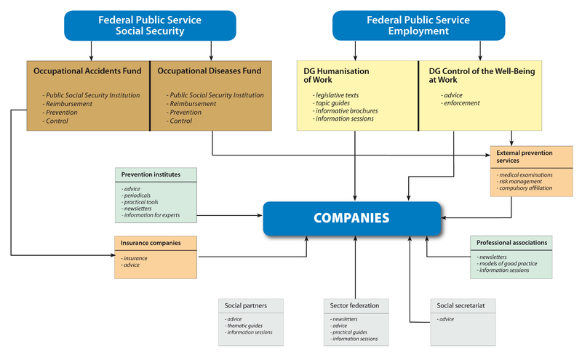

* **OSH auth****orities and inspection services**

|  |  |
| --- | --- |
| Name of the Authority | Federal Public Service Employment, Labour and Social Dialogue. |
| Link | <http://www.emploi.belgique.be> |
| Short abstract | Occupational safety and health (OSH) is a matter within the competence of the Federal Public Service Employment, Labour and Social Dialogue. The main executive agencies are the Directorate General for the Humanization of Work (DG Humanisation du travail – DGHT) and the Directorate General for the Control of the well-being at work (DG Contrôle du bien-être au travail). The Federal Public Service is the responsible administrative body led by the Federal Minister for Work. |
| Link to OSH wiki | <https://oshwiki.eu/wiki/OSH_system_at_national_level_-_Belgium> |

|  |  |
| --- | --- |
| Name of the Authority | DG Control of the Well-being at work (inspection services) |
| Link | <http://www.emploi.belgique.be/defaultTab.aspx?id=6550> |
| Short abstract | The Directorate General for the Control of the Well-being at work is organized in three main Divisions: (1) a Division for Regional Control with 8 Regional Directorates, (2) a Division for chemical risks control with three directorates, one for the prevention of major accidents, one for control policies and one for industrial toxicology, and (3) a Division for knowledge management. It covers all topics as defined by the well-being at work law.  The task of the inspection services is to help reduce accidents and health problems in businesses and public services based on the regulations. They ensure that the rules are adhered to and have an advisory, preventive and repressive role. Another of its tasks is indicating all the loopholes in the legislation and helping the authorities to close these. |
| Link to OSH wiki | <https://oshwiki.eu/wiki/OSH_system_at_national_level_-_Belgium> |

|  |  |
| --- | --- |
| Name of the Authority | DG Humanization of work |
| Link | <http://www.emploi.belgique.be/defaultTab.aspx?id=332> |
| Short abstract | The Directorate General for the Control of the Well-being at work is organized in three Divisions: (1) a Division for the preparation of the legislation, (2) a Division for the promotion of the well-being at work and (3) a Division for social consultation.  The Division for the preparation of the legislation draws up the norms regarding well-being on the shop floor and interprets and evaluates these norms. It also deals with preparing these norms on a European and international level and the implementing of the European and international norms into Belgian law.  The Division of promoting well-being at work arranges for promotion and information regarding well-being at work on an international and Belgian level. It develops action programmes on the distribution and use of “good practices” and networks for exchanging information on well-being at work.  There are provincial committees for promoting work in each province with a view to reaching small businesses more effectively. They are tripartite committees comprising representatives of employers, employees and the administration of which the governors of the provinces are the president. They carry out regional information campaigns controlled by the DG Humanization of Work.  The Division for social consultation on well-being at work organizes social consultation among other things, on the level of norms regarding well-being at work. It also manages the procedures for recognition and approval of the external actors involved in well-being at work. |
| Link to OSH wiki | <https://oshwiki.eu/wiki/OSH_system_at_national_level_-_Belgium> |

Internal link to enforcement indicator by MS

* **Compensation and Insurance bodies**

|  |  |
| --- | --- |
| Name of the Body | Belgian Social Insurance for Occupational Risks |
| Link | <https://www.assuralia.be> |
| Short abstract | Industrial accident insurance is in the hands of private insurers. This system is an important aspect of social security given that it is compulsory for each employer. Accident insurance is compulsory for employers in the private sectors, trainees and persons in apprentiship. Self-employed are exempted from the compulsory system. There exist special regulations for the public sector.  Most insurance institutions have set up a prevention service; its task is to stimulate the prevention of industrial accidents in affiliated businesses. The activities of these prevention services are threefold: Assisting in working out and applying a prevention policy in the affiliated businesses, study and analysis of industrial accidents, study and assessment of the risks, taking action in the areas of information, training and promotion aimed at employees and employers.  Assuralia is the professional association of insurance companies and represents the Belgian and foreign insurance companies operating on the Belgian market. |
| Link to OSH wiki | <https://oshwiki.eu/wiki/OSH_system_at_national_level_-_Belgium> |

|  |  |
| --- | --- |
| Name of the Body | Federal Agency of professional risks (FEDRIS) |
| Link | <https://www.fedris.be/> |
| Short abstract | The remuneration of occupational illnesses is in the hands of Fedris (Federal Agency of professional risks), the former Occupational Illness Fund (Fonds des Maladies Professionnelles). This is a state-controlled institution managed by a management committee in which the social partners are represented. Fedris forms part of the social security, which means that employers are obliged to spend a certain percentage of the total wage sum on financing Fedris. Fedris is under the guardianship of the FPS Social Security.  Since january 2017, the former Occupational Illness Fund and the former Accidents at Work Fund were merged in a new institution called Fedris, the Federal Agency of professional risks.'  The insurance premiums are in relation to the compensation paid to the victims of industrial accidents that have taken place in recent years. The premiums are therefore related to the frequency of the accidents in the company. |
| Link to OSH wiki | <https://oshwiki.eu/wiki/OSH_system_at_national_level_-_Belgium> |

* **Research institutes**

|  |  |
| --- | --- |
| Name of the institute | Directorate DIRACT- DIOVA (Direction de la recherche sur l’amélioration des conditions de travail |
| Link | <http://www.emploi.belgique.be/moduleTab.aspx?id=556&idM=127> |
| Short abstract | Belgium does not run a national OSH research institute. Research in the field of health and safety at work is mainly carried out by the research groups at the universities. The Belgian DG for humanization of work runs a directorate DIRACT- DIOVA (Direction de la recherche sur l’amélioration des conditions de travail), which is responsible for the coordination and promotion of research on the improvement of the working conditions. |
| Link to OSH wiki | <https://oshwiki.eu/wiki/OSH_system_at_national_level_-_Belgium> |

* **Prevention Institutes**

|  |  |
| --- | --- |
| Name of the institute | Constructiv |
| Link | <http://www.constructiv.be> |
| Short abstract | Constructiv is a private service organisation for the construction industry. It is jointly managed by employers and construction workers. It provides information, advice and assistance on the prevention of occupational accidents and illnesses for employers and employees in this sector. |
| Link to OSH wiki | <https://oshwiki.eu/wiki/OSH_system_at_national_level_-_Belgium> |

|  |  |
| --- | --- |
| Name of the institute | Prevent |
| Link | <https://www.prevent.be/> |
| Short abstract | Prevent is a multidisciplinary and private institute, which promotes the quality of working conditions. The institute is active in research and supports, advises and informs companies and institutions as well as insurance companies, external prevention services, professional associations, the social partners, authorities and other stakeholders in society. |
| Link to OSH wiki | <https://oshwiki.eu/wiki/OSH_system_at_national_level_-_Belgium> |

|  |  |
| --- | --- |
| Name of the institute | Provinciaal Veiligheidsinstituut Antwerpen (PVI |
| Link | <https://www.provincieantwerpen.be/aanbod/doe/pvi.html> |
| Short abstract | PVI is a public institution funded by the Province of Antwerp. The institute provides information and guidance concerning prevention, protection and well-being at work and in the private sphere. |
| Link to OSH wiki | <https://oshwiki.eu/wiki/OSH_system_at_national_level_-_Belgium> |

|  |  |
| --- | --- |
| Name of the institute | Prevention & Interim (P&I) |
| Link | <http://www.p-i.be/> |
| Short abstract | For the sector of the temporary employment agencies, a Central Prevention Service P&I (Service Central de Prévention pour le Secteur du Travail Intérimaire, Prévention et Interim) [50] has been created in 1998 by national collective agreement. It is jointly managed by the employers organization Federgon and the unions representing the employees in the sector of the temporary employment agencies. The goal of this non-profit OHS-service is to reduce the degree of working accidents in the sector by enhancing the amount of prevention campaigns and health and safety investigations in the sector. |
| Link to OSH wiki | <https://oshwiki.eu/wiki/OSH_system_at_national_level_-_Belgium> |

* **Standardization Bodies**

|  |  |
| --- | --- |
| Name of the Body | NBN – Bureau de Normalisation |
| Link | <https://www.nbn.be> |
| Short abstract | The NBN – Bureau de Normalisation is the Belgian organization responsible for the development and publication of standards in Belgium. NBN is a semi-governmental institution with juridical responsibility. The NBN represents Belgium at European level, as member of the European Standardization Committee (CEN) and at worldwide level as a member of the International Standardization Organization (ISO). |
| Link to OSH wiki | <https://oshwiki.eu/wiki/OSH_system_at_national_level_-_Belgium> |